SECTION 1: GETTING STARTED

1 | How to Install Python (4:46m)
Welcome to Python.org -> Downloads -> Download python 3 version.
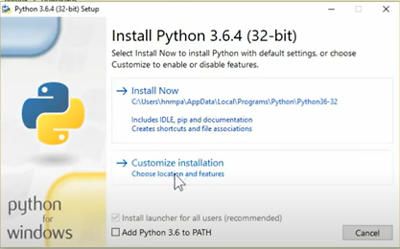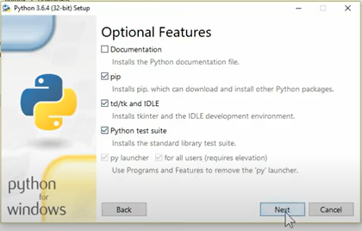

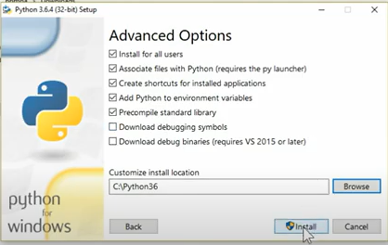
C:\Users\HP>python
Python 3.6.8
Type "help", "copyright", "credits" or "license" for more information.
>>> ^Z

C:\Users\HP>python --version
Python 3.6.8
After installation is completed, check python version in cmd.
To quit: CTRL + Z

2 | First Basic Program in Python (7:2m)
Python is an interpreter language, it generates/modifies pyc file(a cache file to avoid checks unless code is changed) whenever there’s some code change.
Resource: basics.py
To run in CMD: C:\Users\HP>python location\of\the\file\basics.py

3 | Python Data Types(Number, String, List, Tuple, Dictionary) (7:23m)
Immutable -> Number: int, float, long, complex
String: unicode strings
Tuple
Mutable-> List
Dictionary.
C:\Users\HP>python
# number
>>> num = 10
>>> type(num)
<class 'int'>
>>> float(num)
10.0

# string
>>> message = "Hello world"
>>> type(message)
<class 'str'>
>>> message = u"Hello world"
>>> type(message)
<class 'str'>

>>> a = 10
>>> a = 1

# tuple
>>> tup = ('Tom', 'Jerry')
>>> tup
('Tom', 'Jerry')
>>> type(tup)
<class 'tuple'>
>>> tup[0]
'Tom'
>>> tup[1]
'Jerry'
>>> del tup[0]
Traceback (most recent call last):
File "<stdin>", line 1, in <module>
TypeError: 'tuple' object doesn't support item deletion
>>> tup[0] = 'Jack'
Traceback (most recent call last):
File "<stdin>", line 1, in <module>
TypeError: 'tuple' object does not support item assignment

# list
>>> list = ['Tom', 'Jerry']
>>> list[0]
'Tom'
>>> list[1]
'Jerry'
>>> list[1] = 'Jack'
>>> list[1]
'Jack'
>>> del list[0]
>>> list
['Jack']

# dictionary
>>> dic1 = {}
>>> dic2 = dict()
>>> type(dic1)
<class 'dict'>
>>> dic2["one"] = 1
>>> dic2
{'one': 1}

4 | Python Operators (9:39m)
C:\Users\HP>python
>>> a = 10
>>> b = 2
# Basic operators
>>> a + b
12
>>> a - b
8
>>> a * b
20
>>> a / b
5.0
>>> a // b
5
>>> a / 3
3.3333333333333335
>>> a // 3
3
>>> a % b
0
>>> a ** b
100

#Assignment operators
>>> a += b
>>> a
12
>>> a -= b
>>> a
10
>>> a /= b
>>> a
5.0
>>> a //= b
>>> a
2.0
>>> a *= b
>>> a
4.0
>>> a %= b
>>> a
0.0
>>> a = 5
>>> a **= b
>>> a
25

#Conditional operators
>>> a == b
False
>>> a < b
False
>>> a > b
True
>>> a != b
True

#Logical operators
>>> t = True
>>> f = False
>>> t & f
False
>>> t and f
False
>>> t | f
True
>>> t or f
True

#Identity operator
>>> a is 25
True
>>> a is not 25
False

#Membership operator
>>> list = [1,3,5,7,9]
>>> 1 in list
True
>>> 1 not in list
False

5 | Python Numbers and Methods (11:39m)
Install IPython: pip install ipython
IPython is a python shell that provides all available functions with a value on TAB keypress or ?.
Use exit to exit ipython shell
C:\Users\HP>ipython
IPython 7.16.3 -- An enhanced Interactive Python. Type '?' for help.

In [1]: a = 10

In [2]: type(a)
Out[2]: int

In [3]: a = 10.0

In [4]: type(a)
Out[4]: float

In [5]: complex?
Init signature: complex(self, /, *args, **kwargs)
Docstring:
complex(real[, imag]) -> complex number

Create a complex number from a real part and an optional imaginary part.
This is equivalent to (real + imag*1j) where imag defaults to 0.
Type: type
Subclasses:

In [6]: i = 2

In [7]: c = complex(a,i)

In [8]: c
Out[8]: (10+2j)

In [9]: c.imag
Out[9]: 2.0

In [10]: c.imag
Out[10]: 2.0
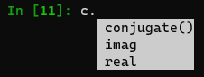
Complex number methods

In [11]: float(10)
Out[11]: 10.0

In [12]: int(10.0)
Out[12]: 10

In [13]: import math

In [14]: math.trunc(10.01)
Out[14]: 10
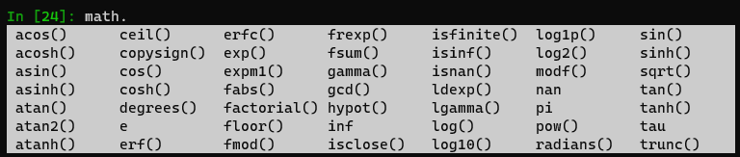
In [20]: import random

In [21]: random.choice(['Play', 'Watch TV', 'Sleep'])
Out[21]: 'Sleep'

In [22]: random.choice(range(0,100))
Out[22]: 33
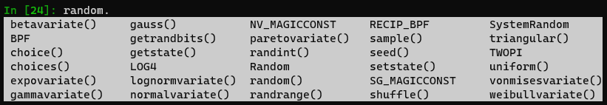

6 | Python Strings and Methods (14:17m)
C:\Users\HP>ipython

In [1]: s = "how are you?"

In [2]: "how" in s
Out[2]: True

In [3]: "how" not in s
Out[3]: False

In [5]: l = "*"

In [6]: l*20
Out[6]: '********************'

In [8]: l *=20

In [9]: l
Out[9]: '********************'

Escape Characters: \n, \t, \r, \s, etc. Refer official docs.
In [10]: p = "new\nline"

In [11]: p
Out[11]: 'new\nline'

In [12]: p.splitlines()
Out[12]: ['new', 'line']

Formatting:
In [13]: s = "name: %s , age: %d" %("Alice", 10)

In [14]: s
Out[14]: 'name: Alice , age: 10'

In [15]: s = "name is {1}, age is {0}".format(10, "Alice")

In [16]: s
Out[16]: 'name is Alice, age is 10'

In [17]: s.split()
Out[17]: ['name', 'is', 'Alice,', 'age', 'is', '10']

In [18]: s.split(",")
Out[18]: ['name is Alice', ' age is 10']

In [19]: s.startswith("n")
Out[19]: True

7 | Python List and Tuple (11:47m)
List indexing: L->R: 0, 1, …. R->L: -1,-2, ….
In [1]: l = ["Tom", 50, "Jerry", 20.5]

In [2]: m = ['Alice', 'apple']

In [3]: l += m

In [4]: l
Out[4]: ['Tom', 50, 'Jerry', 20.5, 'Alice', 'apple']

In [5]: len(l)
Out[5]: 6

In [6]: l.insert(2, '&')

In [7]: l
Out[7]: ['Tom', 50, '&', 'Jerry', 20.5, 'Alice', 'apple']

In [8]: l.pop(2)
Out[8]: '&'

In [9]: l
Out[9]: ['Tom', 50, 'Jerry', 20.5, 'Alice', 'apple']
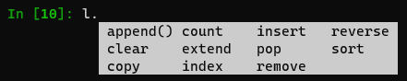

In [1]: t = ()

In [2]: t
Out[2]: ()

In [3]: t = ("tom") #this will define a string

In [4]: t
Out[4]: 'tom'

In [5]: t = ("tom",) #this will define a tuple

In [6]: t
Out[6]: ('tom',)
In [7]: t = ("sat", "sun")

In [8]: t = ("fri", "sat", "sun")

In [9]: t1 = t[1:]
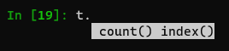
In [14]: t
Out[14]: ('tom',)

In [15]: l = list(t)

In [16]: l
Out[16]: ['tom']

In [17]: t = tuple(l)

In [18]: t
Out[18]: ('tom',)

8 | Slicing in Python (14:32m)
Slicing can be done on strings, tuples and lists.
In [1]: l = [1,3,5,7,11,13]

In [2]: l[-6::2]
Out[2]: [1, 5, 11]

In [3]: l[-1::-2]
Out[3]: [13, 7, 3]

In [4]: l[::-1] #to reverse a string
Out[5]: [13, 11, 7, 5, 3, 1]

# deepcopy
In [1]: l = [1,2,3,4,5]

In [2]: m = l

In [3]: m.append(6)

In [4]: l
Out[4]: [1, 2, 3, 4, 5, 6]

In [5]: m
Out[5]: [1, 2, 3, 4, 5, 6]

In [6]: import copy

In [7]: n = copy.deepcopy(l)

In [8]: n = copy.deepcopy(m)

In [9]: m.append(7)

In [10]: m
Out[10]: [1, 2, 3, 4, 5, 6, 7]

In [11]: n
Out[11]: [1, 2, 3, 4, 5, 6]

In [12]: l
Out[12]: [1, 2, 3, 4, 5, 6, 7]

In [13]: n.append(8)

In [14]: n
Out[14]: [1, 2, 3, 4, 5, 6, 8]

In [15]: m
Out[15]: [1, 2, 3, 4, 5, 6, 7]

9 | Python Dictionary (9:36m)
PS C:\Users\HP> ipython

In [1]: d = {"name": "Tom", "animal": "cat"}

In [2]: d
Out[2]: {'name': 'Tom', 'animal': 'cat'}

In [3]: d["name"]
Out[3]: 'Tom'

In [4]: d["age"] #will face error when accessing non-existing keys
---------------------------------------------------------------------------
KeyError Traceback (most recent call last)
<ipython-input-4-351cab8a0992> in <module>
----> 1 d["age"]

KeyError: 'age'

In [5]: d.get("animal")
Out[5]: 'cat'

In [6]: d.get("age", 10)
Out[6]: 10

In [7]: d
Out[7]: {'name': 'Tom', 'animal': 'cat'}

In [8]: d["age"] = 10

In [9]: d
Out[9]: {'name': 'Tom', 'animal': 'cat', 'age': 10}

In [10]: d.setdefault("type", "cartoon")
Out[10]: 'cartoon'

In [11]: d
Out[11]: {'name': 'Tom', 'animal': 'cat', 'age': 10, 'type': 'cartoon'}

In [12]: d.setdefault("gender")

In [13]: d
Out[13]: {'name': 'Tom', 'animal': 'cat', 'age': 10, 'type': 'cartoon', 'gender': None}

In [14]: del d["type"]

In [15]: d
Out[15]: {'name': 'Tom', 'animal': 'cat', 'age': 10, 'gender': None}

In [17]: d["gender"] = "male"

In [18]: d
Out[18]: {'name': 'Tom', 'animal': 'cat', 'age': 10, 'gender': 'male'}

In [20]: d.items()
Out[20]: dict_items([('name', 'Tom'), ('animal', 'cat'), ('age', 10), ('gender', 'male')])

In [21]: m = {}

In [22]: l = ['a', 'b', 'c']

In [23]: m = m.fromkeys(l)

In [24]: m
Out[24]: {'a': None, 'b': None, 'c': None}

In [25]: d.update(m)

In [26]: d
Out[26]:
{'name': 'Tom',
'animal': 'cat',
'age': 10,
'gender': 'male',
'a': None,
'b': None,
'c': None}
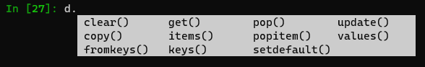

10 | Conditional and decision making Operators in Python (14:11m)
Resource: if_else.py
11 | For and While Loops in Python | by Hardik Patel (13:24m)
Resource: loops.py

12 | Functions and Arguments, Lambda function in Python (13:43m)
Resource: functions.py

13 | Modules, import statement, variable scopes in Python (14:29m)
Resource: calc
local variable has more scope than global variable. global variable can be used anywhere.

14 | Python Package, Inbuilt methods (11m)
__init__.py : add this file to create a folder as package
Resource: calc

15 | Class, Instance, Method concepts using Account application in Python (20:15m)
Resource: user/user.py
...\resources> ipython

In [1]: from user.user import Account

In [2]: a = Account() #creates instance of a class
constructor is called

In [3]: a.accounts
Out[3]: []

In [4]: a.create({})
Provide username

In [5]: a.create({"username": "Zack"})

In [6]: a.accounts
Out[6]: [{'username': 'Zack', 'id': 1}]

In [7]: a.create({"username": "Zack"})
Only one account can be created

In [8]: a.get()
Out[8]: {'username': 'Zack', 'id': 1}

In [9]: a.update(password="123")

In [10]: a.accounts
Out[10]: [{'username': 'Zack', 'id': 1, 'password': '123'}]

In [11]: a.delete()

In [12]: a.accounts
Out[12]: []

16 | Custom decorators in Python with examples (20:43m)
Resource: decorators.py
Resource: user/decorators.py
...\resources> ipython
In [1]: from user.user import Account

In [2]: a = Account()
constructor is called

In [3]: Account.accounts
Out[3]: []

In [4]: a.create({})
Provide username

In [5]: a.create({"username": "Zack"})

In [6]: Account.accounts
Out[6]: [{'username': 'Zack', 'id': 1}]

In [7]: a.create({"username": "Zack"})
Only one account can be created

In [8]: b = Account()
constructor is called

In [9]: b.create({"username": "Zack"})
Only one account can be created

17 | Setup Python virtual environment in Linux (9:14m)

18 | Setup python virtual environment in Windows (5:38m)
…path> python --version
Python 3.6.8
…path > pip freeze
virtualenv==20.16.5
…path > virtualenv my_env
…path > my_env\Scripts\activate
(my_env) …path>deactivate

19 | Handling Exceptions and Create Custom Exception in Python (9:2m)
Resource: exceptions.py

20 | File operations in python (15:48m)
f = open(filename, mode, encoding)
modes: r, w, w+(write&create), a+(append), x(if file not available)

Resource: text.txt
In [1]: f = open('text.txt')

In [2]: f.read()
Out[2]: 'my text file\nthis is next line'

In [3]: f.seek(0)
Out[3]: 0

In [4]: f.read(2)
Out[4]: 'my'

In [5]: f.tell()
Out[5]: 2

In [6]: f.seek(0)
Out[7]: 0

In [8]: print(f.read())
my text file
this is next line

In [9]: f.seek(0)
Out[9]: 0

In [10]: for line in f.readlines():
...: print(line, end="")
...:
my text file
this is next line

In [11]: f.close()

In [12]: with open('text.txt') as f:
...: f.read()
...:
#write
In [13]: f = open('text.txt', 'w+', encoding="utf-8")

In [14]: f.write("Hello")
Out[14]: 5

In [15]: f.writelines('\nworld')

In [16]: f.seek(0)
Out[16]: 0

In [17]: print(f.read())
Hello
world

